

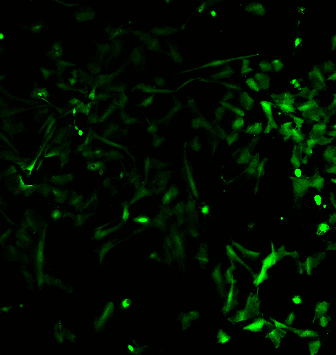

**5kPa Day 1**

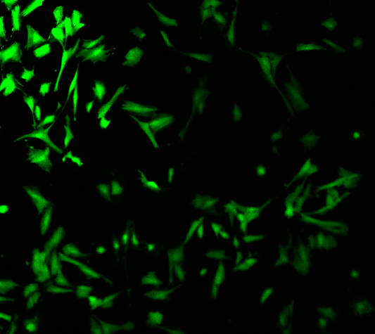

**10kPa Day 1**

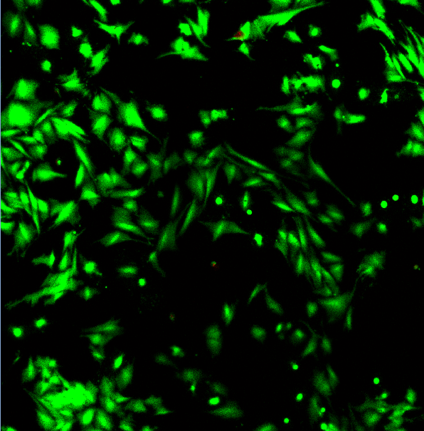

**20kPa Day 1**

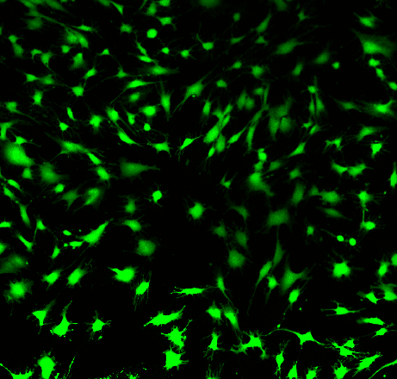

**Plain Glass Slide Day 1**

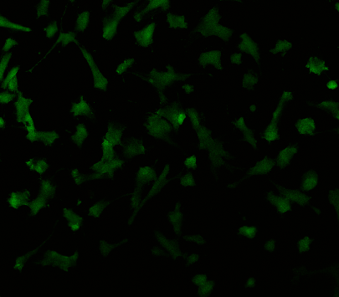

**5kPa Day 3**

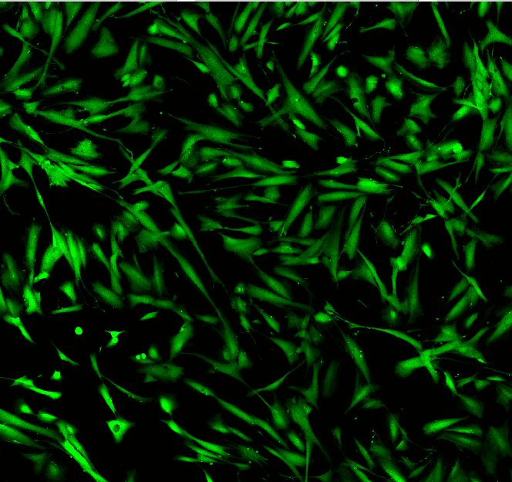

**20kPa Day 3**

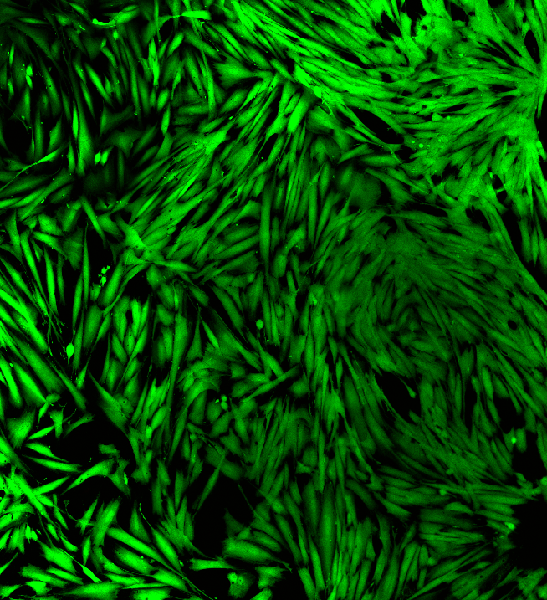

**10kPa Day 3**

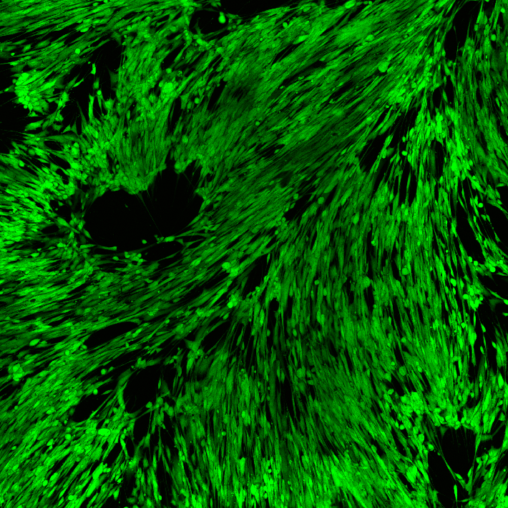

**Plain Glass Slide Day 3**

**Live Cells Dead Cells**

**Cell Viability of Human Vaginal Fibroblasts (HvFs) Seeded on Click Chemistry Functionalized Polyacrylamide Gels.**

Polyacrylamide gels were functionalized via CuAAC (Copper(I)-Catalyzed Azide-Alkyne Cycloaddition) to present RGD motifs for HvFs attachment. Cell viability was assessed using a Live/Dead assay, where Calcein AM stains live cells green, and Ethidium Homodimer-1 stains the nuclei of dead cells red. An increase in cell viability was observed with increasing substrate stiffness and culture duration, indicating improved cell survival and attachment over time.